Taiga Software Testing Project Report Draft
Taiga (Open-Source Agile Project Management System)
GitHub: https://github.com/taigaio

Course: SWENG 881 — SU 2026
Professor: Moraes do Nascimento, PhD
Group: Group 2
Publication Date: 2026-07-14

Group Members:
John Pretz — jjp6846@psu.edu
Yahya Youseef — ymy5376@psu.edu
Devin Caswell — dbc5886@psu.edu

Table of Content
1 Introduction ............................................................................................................. 4
1.1 Test Project Name ........................................................................................... 5
1.2 Revision History .............................................................................................. 5
1.3 Terminology and Definitions ........................................................................... 5
1.4 Name of Approvers and Date of Approval ....................................................... 6
1.5 References ....................................................................................................... 6
1.6 Summary of the Rest of the Test Plan ............................................................ 6
2 Feature Description ................................................................................................. 7
2.1 Overview of Taiga ........................................................................................... 6
2.2 Core Features and Functionalities .................................................................. 6
2.2.1 Create User Story ..................................................................................... 6
2.2.2 Create Task ............................................................................................... 7
2.2.3 Create Issue .............................................................................................. 7
2.2.4 Create Sprint / Milestone ......................................................................... 8
2.2.5 User Registration and Login ..................................................................... 8
Feature Selection Justification......................................................................11
2.3 Application Access .......................................................................................... 9
3 Assumptions ........................................................................................................... 10
4 Test Approach ........................................................................................................ 12
5 Test Suite Structure ............................................................................................... 18
6 Test Environment ................................................................................................... 40
7 Test Execution Strategy and Results ..................................................................... 43
8 Test Effort Estimation ............................................................................................ 50
9 Scheduling and Test Milestones ............................................................................ 52
10 Recommendations on Software Quality ............................................................... 55
11 Conclusion ............................................................................................................ 57

Appendix A – Taiga User Registration/Login Graph .................................................. 58
Appendix B – Authentication Test Execution Results ............................................... 65
Appendix C – Graph-Based Testing Results .............................................................. 67

1. Introduction

1.1 Test Project Name
The application selected for testing is Taiga, an open-source Agile project management platform designed to support both Scrum and Kanban software development methodologies. Taiga provides organizations and development teams with a centralized environment for managing projects, user stories, tasks, issues, sprints, backlogs, and collaborative workflows. The platform helps teams plan, organize, track, and deliver software projects while promoting transparency and continuous collaboration among stakeholders.
Taiga was selected for this project because it contains several workflow-driven features that require extensive user interaction and input validation. These features include project planning, task management, issue tracking, sprint management, and user authentication. The variety of input fields and business rules associated with these functions makes Taiga an appropriate candidate for applying software testing techniques such as Input Domain Modeling (IDM), equivalence partitioning, and graph-based testing.
The primary focus of this testing effort is to evaluate selected Taiga features by identifying input characteristics, partitioning input domains into meaningful equivalence classes, selecting representative values, and creating test cases that effectively assess system behavior. In addition, graph-based testing techniques are applied to the User Registration and Login functionality to analyze workflow transitions and authentication behavior.
The following features were selected for analysis and testing:
- Create User Story
- Create Task
- Create Issue
- Create Sprint / Milestone
- User Registration / Login
These features were chosen because they represent core functionality within the application and involve multiple validation rules, workflow constraints, and user interactions. Testing these features provides meaningful insight into the correctness, reliability, and robustness of the Taiga platform.
1.2 Revision History

Version | Date | Author | Description of Changes
1 | 14-Jul-26 | John Pretz | Initial report draft created
1.1 | Jul-26 | John Pretz | Added Input Domain Modeling analysis
1.2 | Jul-26 | Group 2 | Added partitioning and representative values
1.3 | Jul-26 | Group 2 | Added graph-based testing documentation
2 | TBD | Group 2 | Final submission

1.3 Terminology and Definitions

The following terminology is used throughout this report.
Term | Definition
Agile | An iterative software development methodology emphasizing collaboration and incremental delivery.
Scrum | An Agile framework that organizes work into time-boxed iterations known as sprints.
Kanban | A visual workflow management approach used to track and manage work items.
User Story | A requirement written from the perspective of an end user describing desired functionality.
Sprint | A fixed period during which planned work is completed and reviewed.
Task | A unit of work derived from a user's story or project requirement.
Issue | A defect, enhancement request, question, or problem tracked within the system.
Input Domain Modeling (IDM) | A testing technique that identifies characteristics and partitions of input spaces into equivalence classes.
Equivalence Class | A group of input values expected to produce similar system behavior.
Representative Value | A selected value used to represent a specific equivalence class during testing.
Graph-Based Testing | A testing technique that models system behavior using nodes and transitions.
Edge Coverage | A graph coverage criterion requiring each transition in the graph to be traversed at least once.
JUnit 5 | A Java testing framework used to create and execute automated test cases.
GitHub | A version control and collaboration platform used to store source code and project artifacts.

1.4 Name of Approvers and Date of Approval
Approver | Role | Approval Date
Dr. Nathalia Moraes do Nascimento | Course Instructor | Pending
Group 2 Team Members | Reviewers | Pending

1.5 References
- Taiga Open Source Repository
https://github.com/taigaio/taiga, Taiga Documentation
https://docs.taiga.io
- SWENG 881 Course Materials and Lecture Notes
- Ammann, P., & Offutt, J. (2016). Introduction to software testing. 2nd edition. Cambridge University Press.ISBN: 9781107172012 Ammann, P., & Offutt, J. (2016
- Input Domain Modeling Course Resources
- Graph-Based Testing Course Resources
- JUnit 5 Documentation https://junit.org
- IntelliJ IDEA Documentation
https://www.jetbrains.com/idea

1.6 Summary of the Rest of the Test Plan
This report documents the software testing activities performed on the Taiga Agile Project Management System. The report presents the methodology used to analyze selected application features, identify input characteristics, partition the input domain, select representative test values, and define effective test cases based on a structured coverage criterion.
Section 2 describes the selected application features and provides an overview of the functionality evaluated during testing. Section 3 outlines project assumptions and testing limitations. Section 4 presents the testing strategy, including Input Domain Modeling and Graph-Based Testing approaches. Section 5 describes the test suite structure and developed test cases. Section 6 documents the testing environment and supporting tools. Section 7 summarizes test execution activities and results. Sections 8 through 10 provide project planning information, scheduling activities, and software quality recommendations. Finally, the appendices contain graph-based testing artifacts, authentication test results, and supporting documentation.
The results presented in this report demonstrate the application of software testing principles and provide an evaluation of the selected Taiga features based on systematic and repeatable testing techniques.

2. Feature Description

2.1 Overview of Taiga
Taiga is an open-source Agile project management platform designed to support both Scrum and Kanban software development methodologies. The application enables software development teams to plan, organize, and manage projects throughout the software development lifecycle. Through a web-based interface, Taiga provides functionality for backlog management, sprint planning, issue tracking, task assignment, workflow management, and team collaboration.
The platform is commonly used by software teams to manage project requirements, monitor progress, assign work, and track issues. By providing a centralized environment for project management activities, Taiga helps teams improve organization, communication, and productivity. Because these capabilities are central to Agile development workflows, ensuring that they function correctly is essential to overall software quality.
The selected features represent the primary workflow objects within the application and are frequently used during normal project operations. As a result, they provide suitable candidates for systematic software testing and quality evaluation.

2.2 Core Features and Functionalities
The testing effort focused on five core features within Taiga that represent key project management and workflow activities. These features were selected because they contain multiple user inputs, validation requirements, and workflow dependencies that make them suitable for software testing.

2.2.1 Create User Story
User Stories represent high-level requirements or functionality requested by end users. They serve as the foundation of Agile planning and backlog management.
The Create User Story feature allows users to:
- Define a story subject and description
- Assign story points and estimates
- Assign project members
- Add tags and classifications
- Associate stories with milestones or sprints
- Mark stories as blocked when dependencies exist
Because user stories contain several required and optional inputs, this feature provides a broad range of opportunities for testing input validation, assignment rules, workflow constraints, and business-rule enforcement.

2.2.2 Create Task
Tasks represent individual units of work associated with user stories or project activities. They are used to break larger requirements into manageable and trackable components.
The Create Task feature allows users to:
- Create task subjects and descriptions
- Link tasks to user stories
- Assign tasks to project members
- Associate tasks with milestones
- Track progress and completion status
- Manage scheduling information and due dates
Task creation involves multiple dependency relationships and assignment constraints. Because tasks may be linked to user stories and milestones, this feature provides opportunities to test workflow consistency, cross-field dependencies, and project-specific validation requirements.

2.2.3 Create Issue
Issues are used to track defects, enhancement requests, operational concerns, and project-related questions identified during development.
The Create Issue feature allows users to:
- Define issue subjects and descriptions
- Classify issues by type
- Assign severity and priority levels
- Associate issues with users and milestones
- Track issue status through resolution
Unlike user stories and tasks, issues contain additional classification fields such as type, severity, and priority. These fields create numerous combinations of valid and invalid inputs, making the feature particularly useful for testing business rules and validation logic.

2.2.4 Create Sprint / Milestone
Sprints, also referred to as milestones, represent time-boxed iterations used for planning and managing Agile development activities.
The Create Sprint / Milestone feature allows users to:
- Define sprint names
- Establish start and finish dates
- Organize planned work
- Associate project items with a sprint
- Support project scheduling and release planning
This feature contains date validation requirements, scheduling rules, and uniqueness constraints that are appropriate for evaluating workflow consistency, boundary conditions, and business-rule enforcement.

2.2.5 User Registration and Login
User Registration and Login provide authentication and access-control functionality within the application.
The Registration feature allows users to:
- Create new user accounts
- Define usernames and passwords
- Register unique email addresses
- Configure account profile information
The Login feature allows users to:
- Authenticate using valid credentials
- Access application resources
- Maintain secure session access
- Enforce account restrictions and validation requirements
Authentication is one of the most critical functions within the application because it controls access to all other features. Registration and login workflows contain multiple validation rules, uniqueness requirements, and decision paths that make them suitable for both Input Domain Modeling and Graph-Based Testing.

Feature Selection Justification
The five selected features were chosen because they represent the primary workflow components of the Taiga Agile Project Management System and are frequently used during normal project operations. Each feature contains multiple user inputs, validation requirements, workflow dependencies, and business rules that make them well suited for software testing.
The Create User Story and Create Task features were selected because they form the foundation of Agile project planning and execution. The Create Issue feature introduces additional classification fields such as severity, priority, and issue type, providing opportunities to evaluate complex input combinations and business-rule enforcement. The Create Sprint / Milestone feature contains scheduling logic, date validations, and uniqueness constraints that support testing of workflow consistency and boundary conditions. Finally, the User Registration and Login feature was selected because it serves as the primary entry point to the application and contains numerous validation rules and decision paths suitable for both Input Domain Modeling and Graph-Based Testing.
Collectively, these features provide broad coverage of Taiga's functionality and allow the testing team to evaluate input validation, workflow behavior, business-rule enforcement, and overall software quality.

2.3 Application Access
Taiga is accessed through a web-based interface and supports multi-user project collaboration. Users interact with the system through standard web browsers such as Google Chrome and Mozilla Firefox.
For this project, testing was performed using a Taiga deployment configured for evaluation and testing purposes. Test user accounts were created to execute the selected test scenarios and validate application behavior under various valid and invalid input conditions.

Application Repository
The source code for the application under test is publicly available through GitHub.
Taiga Open-Source Repository:
https://github.com/taigaio/taiga
The repository contains the application source code, documentation, issue tracking information, release notes, and development resources associated with the Taiga platform.

Test Team Repository
The testing team maintained a dedicated GitHub repository throughout the project to organize and store project deliverables and testing artifacts.
Test Team Repository:
Insert Team GitHub Repository URL Here
The repository contains:
- Input Domain Modeling documentation
- Equivalence partitioning analysis
- Representative value selections
- Test case definitions
- Graph-Based Testing artifacts
- Screenshots and execution evidence
- JUnit test implementations
- IntelliJ IDEA project files
- Project reports and supporting documentation
GitHub served as the primary version-control and collaboration platform for the project, allowing team members to manage revisions, track changes, and maintain a centralized location for project materials.

Tools Used for Access and Testing
The following tools were used during project development and testing:
- IntelliJ IDEA Community Edition
- Java Development Kit (JDK)
- JUnit 5 Testing Framework
- GitHub Version Control
- Google Chrome
- Mozilla Firefox
- Microsoft Word
Automated testing activities were performed using IntelliJ IDEA and JUnit 5, while GitHub was used to manage project artifacts and support collaboration among team members. These tools provided a consistent environment for test development, execution, documentation, and analysis throughout the project.

Appendix A: Graph: Tiga User Registration/Login Control Flow Graph

- Taiga User Registration/Login Graph.
The control flow graph represents the Taiga user authentication workflow by showing the sequence of registration and login actions, decision points, and possible success or failure outcomes using numbered nodes and directed edges.
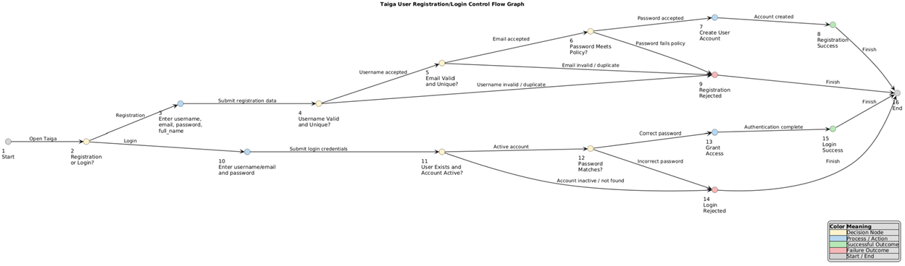
Table A.1: Node Description:
The node description table explains the purpose of each numbered node in the graph and identifies the specific action, validation step, or system state represented by each node.
Node | Description
1 | Start Taiga authentication
2 | User selects Registration or Login
3 | Enter username, email, password, full name
4 | Validate username format and uniqueness
5 | Validate email format and uniqueness
6 | Validate password policy requirements
7 | Create Taiga user account
8 | Registration successful
9 | Registration rejected
10 | Enter username/email and password
11 | Verify user exists and account is active
12 | Verify password correctness
13 | Grant access to Taiga
14 | Login rejected
15 | Login successful
16 | End authentication process

Table A.2: Edge Descriptions:
The edge description table defines the transitions between nodes and describes the conditions or actions that allow the workflow to move from one state to another.
Edge | Description
1 → 2 | Open authentication
2 → 3 | User selects Registration
2 → 10 | User selects Login
3 → 4 | Submit registration information
4 → 5 | Username accepted
4 → 9 | Username invalid
5 → 6 | Email accepted
5 → 9 | Email invalid or duplicate
6 → 7 | Password meets policy
6 → 9 | Password fails policy
7 → 8 | Create account
8 → 16 | Registration complete
9 → 16 | Registration failed
10 → 11 | Submit login credentials
11 → 12 | Account active
11 → 14 | Account inactive
12 → 13 | Passwords correct
12 → 14 | Password incorrect
13 → 15 | Grant access
15 → 16 | Login successful
14 → 16 | Login failed

Table A.3: Metrics/Statistics
The graph statistics section summarizes the structure of the control flow graph by reporting the number of nodes, edges, decision points, and cyclomatic complexity.
Metric | Value
Number of Nodes | 16
Number of Edges | 20
Entry Node | 1
Exit Node | 16
Decision Nodes | 2, 4, 5, 6, 11, 12
There are 20 directed edges in the graph

Coverage Criterion:
The selected graph coverage criteria are Edge Coverage. Edge Coverage requires that every edge in the control flow graph be traversed at least once by the test suite. This criterion was selected because it provides confidence that every decision branch in the authentication workflow is exercised while keeping the number of test cases manageable.

Independent Test Paths:
The test paths section identifies the independent execution paths through the graph and maps each path to a specific registration or login scenario to demonstrate coverage of different system behaviors.
Path | Node Sequence | Scenario
P1 | 1 → 2 → 3 → 4 → 5 → 6 → 7 → 8 → 16 | Successful registration
P2 | 1 → 2 → 3 → 4 → 9 → 16 | Invalid username
P3 | 1 → 2 → 3 → 4 → 5 → 9 → 16 | Duplicate email
P4 | 1 → 2 → 3 → 4 → 5 → 6 → 9 → 16 | Weak password
P5 | 1 → 2 → 10 → 11 → 12 → 13 → 15 → 16 | Successful login
P6 | 1 → 2 → 10 → 11 → 14 → 16 | Inactive account
P7 | 1 → 2 → 10 → 11 → 12 → 14 → 16 | Incorrect password

Initial Observation:
The seven test paths collectively traverse every edge in the authentication control flow graph. Therefore, the selected Edge Coverage criterion is satisfied. The graph includes both successful and unsuccessful registration and login scenarios, ensuring that all major validation rules and decision branches are exercised.

Appendix B: Input Domain Modeling Test Tables

B.1 User Story Test Cases:
Test ID | Input Variables | Test Condition | Test Data / Values | Expected Result
US-01 | Subject, Description, Points, Assigned To, Milestone, Status | Base valid input | Subject: "New Login Feature"; Description provided; Points: 5; Valid assigned user; Valid milestone | User story is created successfully
US-02 | Subject | Empty/invalid subject | Subject: empty or whitespace only | System rejects user story creation
US-03 | Assigned To, Assigned Users | Invalid user assignment | Assigned user does not belong to project | System rejects invalid assignment
US-04 | Points, Status, Is Blocked | Boundary/state validation | Invalid points value or blocked state without required information | System rejects invalid input combination

B.2 Task Test Cases:
Test ID | Input Variables | Test Condition | Test Data / Values | Expected Result
TK-01 | Subject, Description, User Story, Assigned To, Due Date | Base valid input | Valid subject; description; linked user story; assigned user; future due date | Task is created successfully
TK-02 | Subject | Empty/invalid subject | Subject: empty or whitespace only | System rejects task creation
TK-03 | Assigned To, User Story | Invalid relationship | The assigned user or user story does not exist | The system rejects an invalid relationship
TK-04 | Due Date, Is Blocked, Status | Boundary/state validation | Past due date or invalid blocked state | The system rejects invalid input

B3. Issue Test Cases:
Test ID | Input Variables | Test Condition | Test Data / Values | Expected Result
IS-01 | Subject, Description, Type, Severity, Priority, Assigned To | Base valid input | Valid subject; description; issue type; severity; priority; assigned user | Issue is created successfully
IS-02 | Subject | Empty subject | Subject: empty | System rejects issue creation
IS-03 | Type, Severity, Priority | Invalid issue classification | Invalid type/severity/priority value | System rejects invalid classification
IS-04 | Assigned To, Milestone, Status | Invalid relationship/state | Invalid assigned user or milestone state | System rejects invalid input

B.4 Sprit/Milestone Test Cases:
Test ID | Input Variables | Test Condition | Test Data / Values | Expected Result
SP-01 | Name, Estimated Start, Estimated Finish, Sprint State | Base valid input | Name: Sprint 1; Valid start date; Valid finish date; Valid sprint state | Sprint/Milestone is created successfully
SP-02 | Name | Missing required field | Name: empty | System rejects sprint creation
SP-03 | Estimated Start, Estimated Finish | Date validation | Finish date before start date | System rejects invalid date range
SP-04 | Sprint State | Invalid state value | Unsupported sprint state | System rejects invalid state transition
B.5 User Registration/Login Test Cases
Test ID | Input Variables Tested | Test Condition | Test Data | Expected Result
AU-01 | Username, Email, Password, Full Name | Base valid registration | Valid username, valid email, valid password, valid full name | User account is created successfully
AU-02 | Username | Username validation | Invalid username format or duplicate username | Registration is rejected
AU-03 | Email | Email validation | Invalid email format or duplicate email | Registration is rejected
AU-04 | Password | Password policy validation | Empty password or password below minimum requirements | Registration is rejected
AU-05 | Login Credential, Is Active | Login validation | Valid username/email and password for active account | User is authenticated and access is granted

B.1 User Story Test Case Execution Results:
Test ID | Expected Result | Actual Result | Pass/Fail | Defect Found
US-01 | The user story was created successfully. | Returned true, and the user's story was created successfully using valid input values. | Pass | No defect found
US-02 | User story creation is rejected because the subject is required. | Returned false, and the user's story was rejected due to an empty subject. | Pass | No defect found
US-03 | User story creation is rejected because the assigned user is not a valid project member. | Returned false, and the invalid project member was rejected. | Pass | No defect found
US-04 | User story creation is rejected because the story points value is invalid. | Returned false, and the negative story points value was rejected. | Pass | No defect found

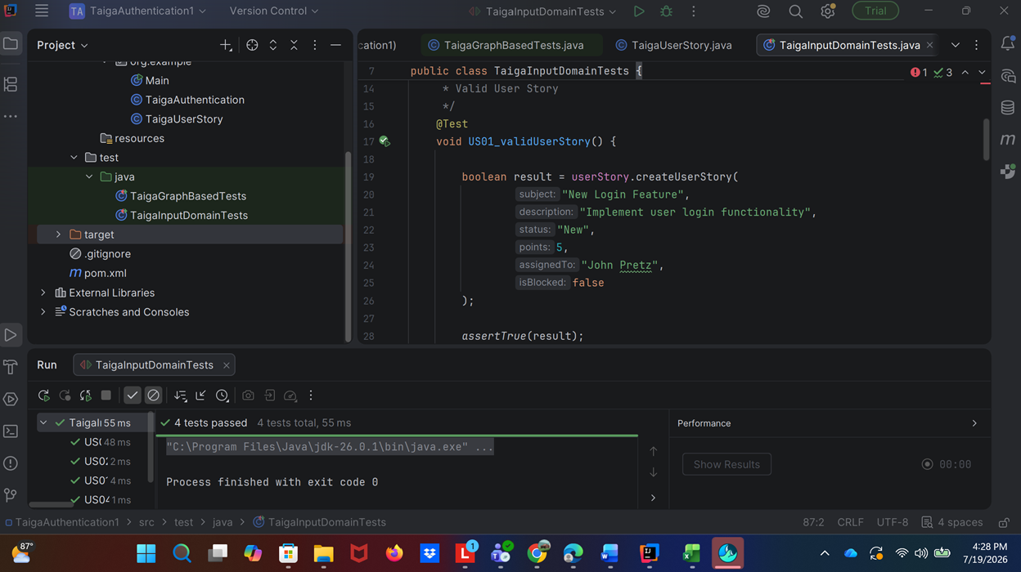The User Story input domain test cases were executed using JUnit 5 in IntelliJ IDEA. All four test cases passed successfully, and no defects were identified during execution. The implemented validation logic correctly handled valid inputs, required-field validation, invalid user assignments, and boundary-value validation for story points.
B.2 Task Test Cases Execution Results:
Test ID | Expected Result | Actual Result | Pass/Fail | Defect Found
TK-01 | The task is created successfully using valid input values. | Returned true, and the task was created successfully with a valid subject, user story relationship, assigned user, due date, and status. | Pass | No defect found
TK-02 | Task creation is rejected because the subject is required. | Returned false, and the task was rejected due to an empty subject. | Pass | No defect found
TK-03 | Task creation is rejected because the related user story and assigned user are invalid for project references. | Returned false, and the invalid user story relationship and assigned user were rejected. | Pass | No defect found
TK-04 | Task creation is rejected because the due date is invalid (in the past). | Returned false, and the task was rejected because the due date was earlier than the current date. | Pass | No defect found

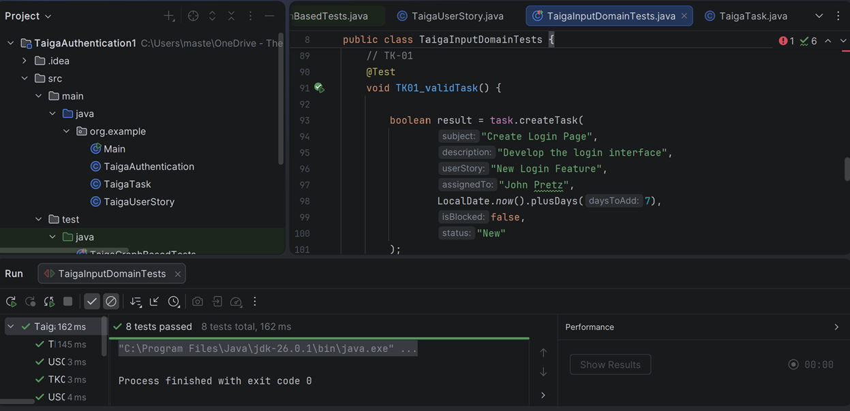All four Task test cases (TK-01 through TK-04) executed successfully and passed, confirming that the task creation functionality correctly handles valid inputs, empty subjects, invalid user story relationships, and invalid due dates according to the specified requirements.

B3. Issue Test Cases Execution Results:
Test ID | Expected Result | Actual Result | Pass/Fail | Defect Found
IS-01 | The issue is created successfully using valid input values. | Returned true, and the issue was created successfully with a valid subject, description, issue type, severity, priority, and assigned user. | Pass | No defect found
IS-02 | System rejects issue creation because the subject field is required and cannot be empty. | Returned false, and the issue was rejected because the subject field was left blank. | Pass | No defect found
IS-03 | System rejects issue creation because the issue type, severity, or priority contains an invalid value. | Returned false, and the invalid issue classification values were rejected by the system. | Pass | No defect found
IS-04 | System rejects issue creation because the assigned user or milestone/state relationship is invalid. | Returned false, and the invalid assigned user relationship was rejected by the system. | Pass | No defect fund

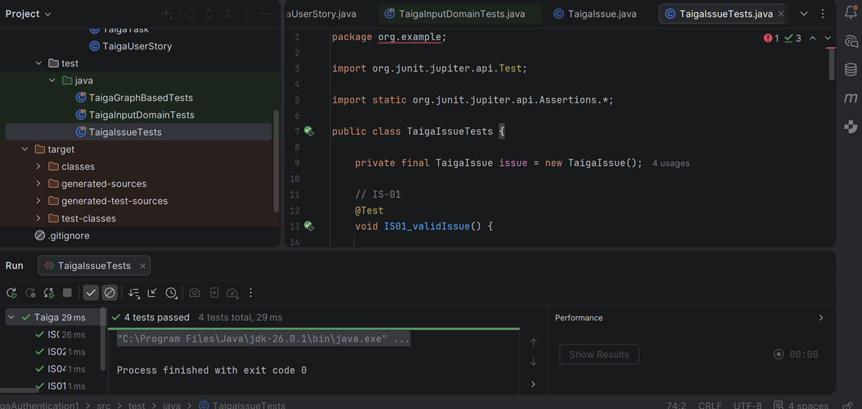All four Issue test cases (IS-01 through IS-04) passed successfully, demonstrating that issue creation functions correctly for valid inputs and appropriately rejects invalid subjects, classifications, and relationship/state values.

B.4 Sprit/Milestone Test Cases Execution Results:
Test ID | Expected Result | Actual Result | Pass/Fail | Defect Found
SP-01 | Sprint/Milestone is created successfully using valid input values. | Returned true, and the sprint was created successfully with a valid name, start date, finish date, and sprint state. | Pass | No defect found
SP-02 | System rejects sprint creation because the name is required. | Returned false, and the sprint was rejected because the name field was empty. | Pass | No defect found
SP-03 | System rejects sprint creation because the finish date occurs before the start date. | Returned false, and the sprint was rejected due to an invalid date range. | Pass | No defect found
SP-04 | System rejects sprint creation because the sprint state contains an invalid value. | Returned false, and the unsupported sprint state value was rejected. | Pass | No defect found

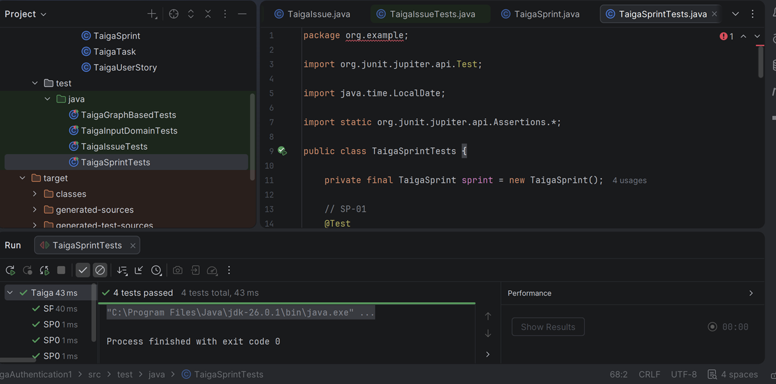All four Sprint/Milestone test cases (SP-01 through SP-04) passed successfully, verifying that sprint creation accepts valid input and correctly rejects missing required fields, invalid date ranges, and unsupported sprint state values.

B.5 User Registration/Login Test Cases Execution Results:
Test ID | Expected Result | Actual Result | Pass/Fail | Defect Found
AU-01 | User account is created successfully using valid registration data. | Returned true, and the user account was successfully created with a valid username, email, password, and full name. | Pass | No defect found
AU-02 | Registration is rejected because the username is invalid or already exists. | Returned false, and the registration request was rejected due to an invalid username. | Pass | No defect found
AU-03 | Registration is rejected because the email format is invalid or already exists. | Returned false, and the registration request was rejected due to an invalid email address. | Pass | No defect found
AU-04 | Registration is rejected because the password does not meet minimum requirements. | Returned false, and the registration request was rejected because the password was empty or invalid. | Pass | No defect found
AU-05 | The user is authenticated, and access is granted when valid login credentials are provided for an active account. | Returned true, and the user was successfully authenticated using valid credentials on an active account. | Pass | No defect found

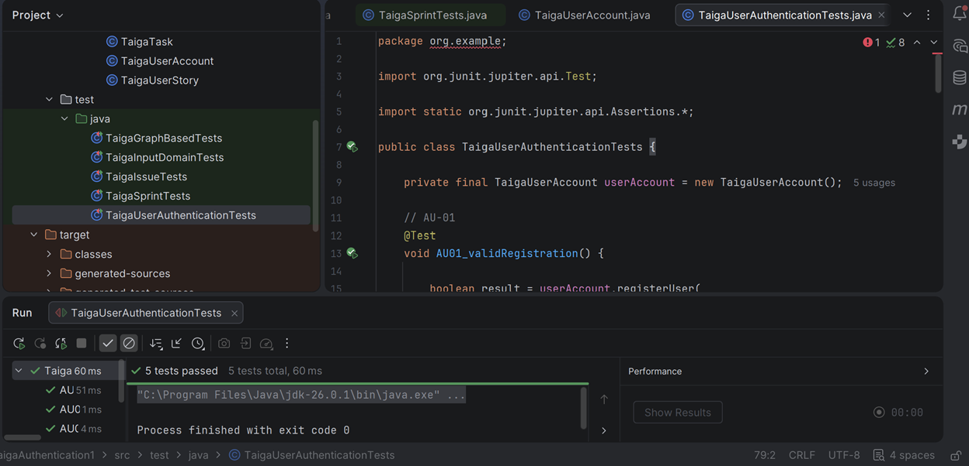All five Account/User Authentication test cases (AU-01 through AU-05) passed successfully, demonstrating that user registration and login functions correctly handle valid credentials and enforce username, email, password, and account-status validation rules.

Appendix C: Taiga User Registration/Login Graph-Based Test Set and Execution Template

Coverage Criterion: Edge Coverage
Objective:
The test cases are designed to execute every transition (edge) in the Taiga User Registration/Login control flow graph at least once.
Graph-Based Test Cases:
Test ID | Scenario | Path Through Graph Nodes | Input Condition | Expected Result | Actual Result | Status
GB-01 | Valid Registration | 1 → 2 → 3 → 4 → 5 → 6 → 7 → 8 → 16 | Valid username, valid email, valid password, valid full name | Account is created successfully and registration completes
GB-02 | Invalid Username During Registration | 1 → 2 → 3 → 4 → 9 → 16 | Username is invalid or already exists | Registration is rejected
GB-03 | Duplicate Email During Registration | 1 → 2 → 3 → 4 → 5 → 9 → 16 | Username valid, email already exists | Registration is rejected
GB-04 | Password Policy Failure | 1 → 2 → 3 → 4 → 5 → 6 → 9 → 16 | Password does not meet required policy | Registration is rejected
GB-05 | Valid Login | 1 → 2 → 10 → 11 → 12 → 13 → 15 → 16 | Existing active user enters correct password | User is authenticated and login succeeds
GB-06 | Inactive Account Login | 1 → 2 → 10 → 11 → 14 → 16 | User account exists but is inactive | Login is rejected
GB-07 | Incorrect Password Login | 1 → 2 → 10 → 11 → 12 → 14 → 16 | Existing user enters incorrect password | Login is rejected

Graph Edge Coverage Mapping:
Edge | Covered By Test Case
1 → 2 | GB-01, GB-05
2 → 3 | GB-01
2 → 10 | GB-05
3 → 4 | GB-01
4 → 5 | GB-01
4 → 9 | GB-02
5 → 6 | GB-01
5 → 9 | GB-03
6 → 7 | GB-01
6 → 9 | GB-04
7 → 8 | GB-01
8 → 16 | GB-01
9 → 16 | GB-02, GB-03, GB-04
10 → 11 | GB-05
11 → 12 | GB-05
11 → 14 | GB-06
12 → 13 | GB-05
12 → 14 | GB-07
13 → 15 | GB-05
14 → 16 | GB-06, GB-07
15 → 16 | GB-05

Graph-Based Test Execution Results:
Test ID | Expected Result | Actual Result | Pass/Fail | Defect Found
GB-01 | Account created successfully | Returned true, and account creation completed successfully | Pass | No defect found
GB-02 | Registration rejected | Returned false and invalid username was rejected | Pass | No defect found
GB-03 | Registration rejected | Returned false and duplicate email was rejected | Pass | No defect found
GB-04 | Registration rejected | Returned false and weak password was rejected | Pass | No defect found
GB-05 | Login successful | Returned true and access was granted | Pass | No defect found
GB-06 | Login rejected | Returned false and inactive account was denied access | Pass | No defect found
GB-07 | Login rejected | Returned false and incorrect password was rejected | Pass | No defect found

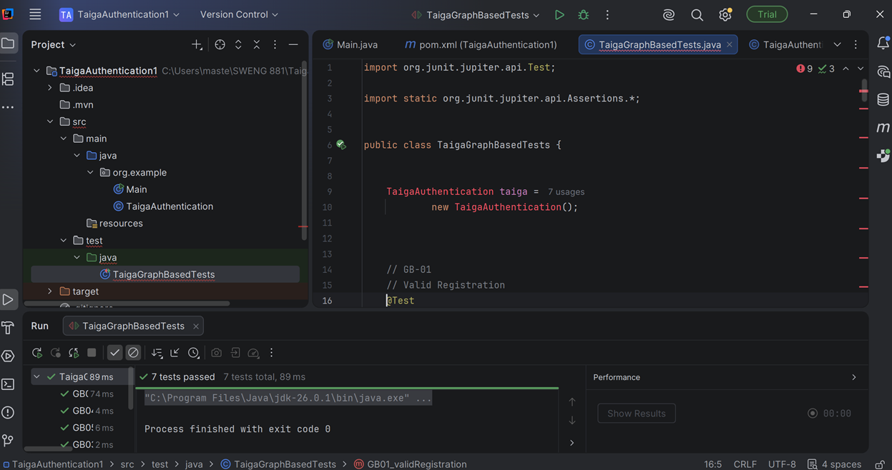The illustration above demonstrates that the graph-based test cases were executed using JUnit 5 in IntelliJ IDEA. All seven test cases passed, demonstrating that the selected Edge Coverage criterion was achieved by exercising all major registration and login decision branches.

